Hear中加入原X7 index中的
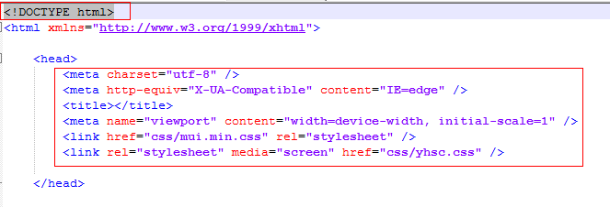
<!DOCTYPE html>

<link href="css/mui.min.css" rel="stylesheet" />
<link rel="stylesheet" media="screen" href="css/yhsc.css" />

在body中加入
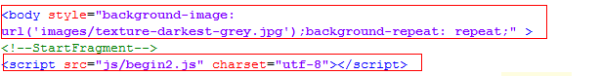
<body style="background-image: url('images/texture-darkest-grey.jpg');background-repeat: repeat;" ><!--StartFragment-->
<script src="js/begin2.js" charset="utf-8"></script>

//页脚
<footer>
<div class="container">
<p class="pull-left">
<span>© BISENSE&amp;SWM MOTORS 版权所有</span>
<a class="pull-right" href="#top">
</a></p><div class="up"><a class="pull-right" href="#top">
<i class="fa fa-angle-up"></i>
</a></div><a class="pull-right" href="#top">
</a>
</div>
</footer>

注意要放在原index同级的目录里
如果是在index的下级目录，在前面加../

<!DOCTYPE html>

<link href="../css/mui.min.css" rel="stylesheet" />
<link rel="stylesheet" media="screen" href="../css/yhsc.css" />

<script src="../js/begin2.js" charset="utf-8"></script>

<footer>
<div class="container">
<p class="pull-left">
<span>© BISENSE&amp;SWM MOTORS 版权所有</span>
<a class="pull-right" href="#top">
</a></p><div class="up"><a class="pull-right" href="#top">
<i class="fa fa-angle-up"></i>
</a></div><a class="pull-right" href="#top">
</a>
</div>
</footer>

